Muhammad Izham Bin Norhamadi B032020039

# Lab 7 Node-Red for Android

## Task 1: Steps (Run Hello World)

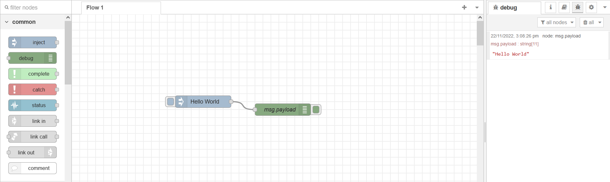

Figure 1 Running "Hello World" message payload

## Task 2: Installing termux-api package in smartphone

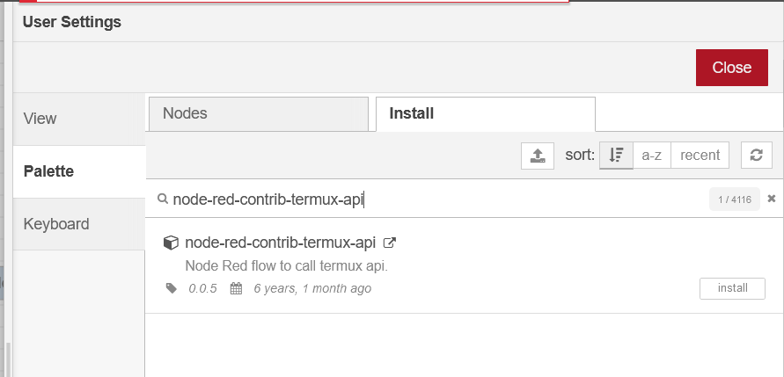

Figure 2 Installing termux API package

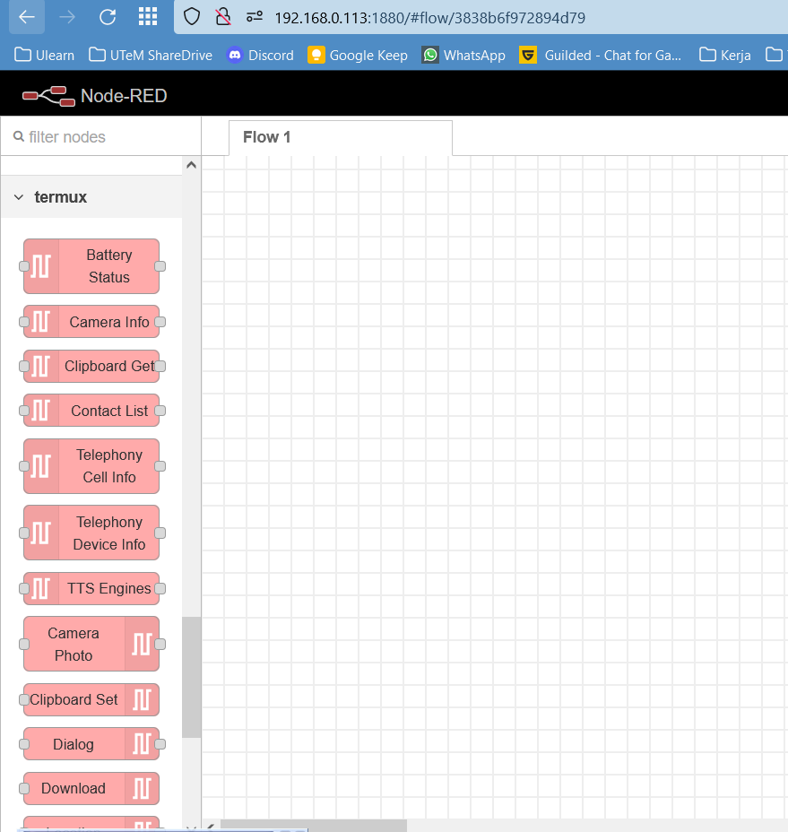

Figure 3 termux API pallete

## Task 3: Run modules in Termux

|  |  |  |
| --- | --- | --- |
| Modules | Flows | Result |
| Battery Status |  |  |
| Location |  |  |
| TTS Speak |  | TTS speak message of current timestamp on mobile: |
| Device Info |  |  |
| Wifi Info |  |  |
| Wifi Scan |  |  |